

**EE 463 HARDWARE PROJECT**

**THD Defenders**

**Bekir Caner YAĞCI 2031607**

**Tuna YILDIZ 2031650**

**Uğur Can YILMAZ 2031680**

**Course Instructor: Ozan KEYSAN**

**Course Assistant: İlker ŞAHİN**

Table of Contents

1. INTRODUCTION 3

2. TOPOLOGY SELECTION 3

3. COMPUTER SIMULATIONS 4

4. COMPONENT SELECTION 9

4.1 THREE PHASE DIODE RECTIFIER 9

4.2 BUCK CONVERTER 11

4.2.1 IGBT COMPONENT 11

4.2.2 DRIVER CIRCUIT 12

4.2.3 PWM TECHNIQUE 13

4.2.4 DC MOTOR (LOAD) 14

4.2.5 FREE-WHEELING DIODE 15

5. EXPERIMENTAL WORK 16

5.1 Three Phase Diode Rectifier 16

5.2 Buck Converter 19

5.3 Thermal Design Components 21

5.4 DC Motor 22

6. CONCLUSION & COMMENTS 25

7. REFERENCES 25

APPENDICES 26

# INTRODUCTION

In this project, controlled rectifier that is used to drive a direct current (DC) motor is implemented. The diode rectifier & buck converter topology is selected to control the separately excited DC motor. Autotransformer (variac) is used as three-phase AC grid power input and soft starter. The output of the variac is connected to the three-phase full-bridge diode rectifier, and its output is paralleled with a 680µF capacitor in order to smooth the output voltage of the diode rectifier. After that, semiconductor switch IGBT, and free-wheeling diode (FWD) is connected to implement the buck converter topology. Finally, FWD is parallel connected with the armature terminals of the DC motor.

For the IGBT gate drive circuit, variable pulse width modulation (PWM) signal is generated by Arduino Mega and amplified by TLP 250 optocoupler. This signal is used to regulate the voltage that is the speed between the terminals of the DC motor.

This report includes the reasons and the details about the selected topology, computer simulations of the selected drive topology, and the detailed test results of the implemented hardware drive system. Finally, comments and the conclusions are discussed.

# TOPOLOGY SELECTION

**Three Phase Diode or Thyristor Rectifier?**

In this project, it is required to design the dc motor controller by using either with three-phase thyristor rectifier or diode rectifier with a buck. These options have own advantages and disadvantages. For three phase thyristor rectifier, it is hard to control the thyristors with given firing signal because the firing signal should be synchronized with the three-phase system. However, for buck converter, there is no need for any kind of synchronization since the IGBT or MOSFET have own gate driver circuit. Therefore it seems that the buck converter with three-phase diode rectifier was seen the best solution. For this reason, three-phase diode rectifier is selected for the dc motor controller design.

**Shunt or Series Connection on Motor Terminals?**

In this project since the three-phase diode rectifier is selected, buck converter is needed to adjust voltage level at the input terminals of dc motor. In buck converter, in order to have smooth dc output, there should be inductor between the gate driver circuit and motor terminals. However, for high voltage applications finding proper inductor can be a bit expensive. By considering these situations, the connection type of the dc motor becomes important.

* For Shunt Connection = 13.6 H
* For Series Connection = 260 µH

As it seen from the shunt connection, inductor value is high enough to make the input voltage of dc motor smooth. Therefore, shunt connection is selected for controlling the dc motor speed project. Moreover, characteristics of the dc motor connections are in figure 2.1.

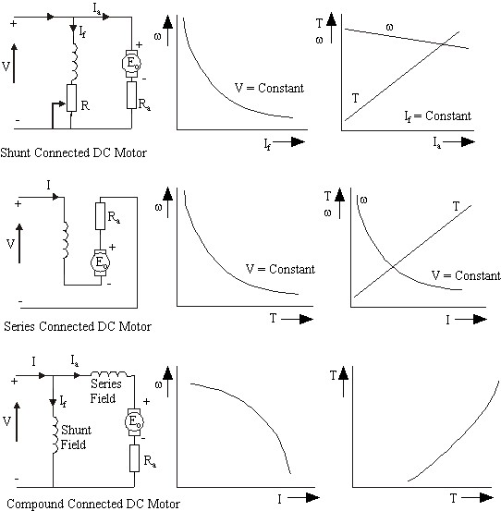

Figure 2.1 Speed and Torque Characteristics of Dc Motor Connections

Those considerations are the basis of this project.

# COMPUTER SIMULATIONS

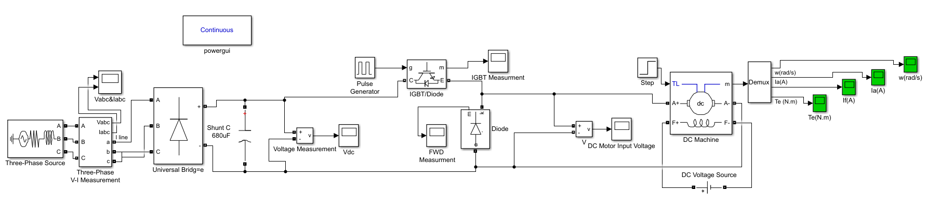

Figure 3.1: Simulink simulation schematic

Computer simulation of the overall system is implemented on MATLAB/Simulink software to select the components with appropriate values and observe the performance characteristics of the drive. Three phase source of phase-to-phase 180Vrms is connected to diode rectifier. A shunt capacitor of 680 µF is paralleled at the output of the rectifier. 0 - 99% duty cycle, 15V amplitude, 3.9 kHz PWM signal is generated by the pulse generator block, and inputted to IGBT/Diode block that is connected to the capacitor. Finally, a free-wheeling diode which is paralleled with the DC machine is connected to the emitter side of the IGBT. The overall schematic can be seen from the figure 3.1.

Various duty cycle cases for PWM block are simulated to determine the ratings of the components. However to simplify the understanding only the figures of 70% duty cycle are shown in figure 3.2-3.8.

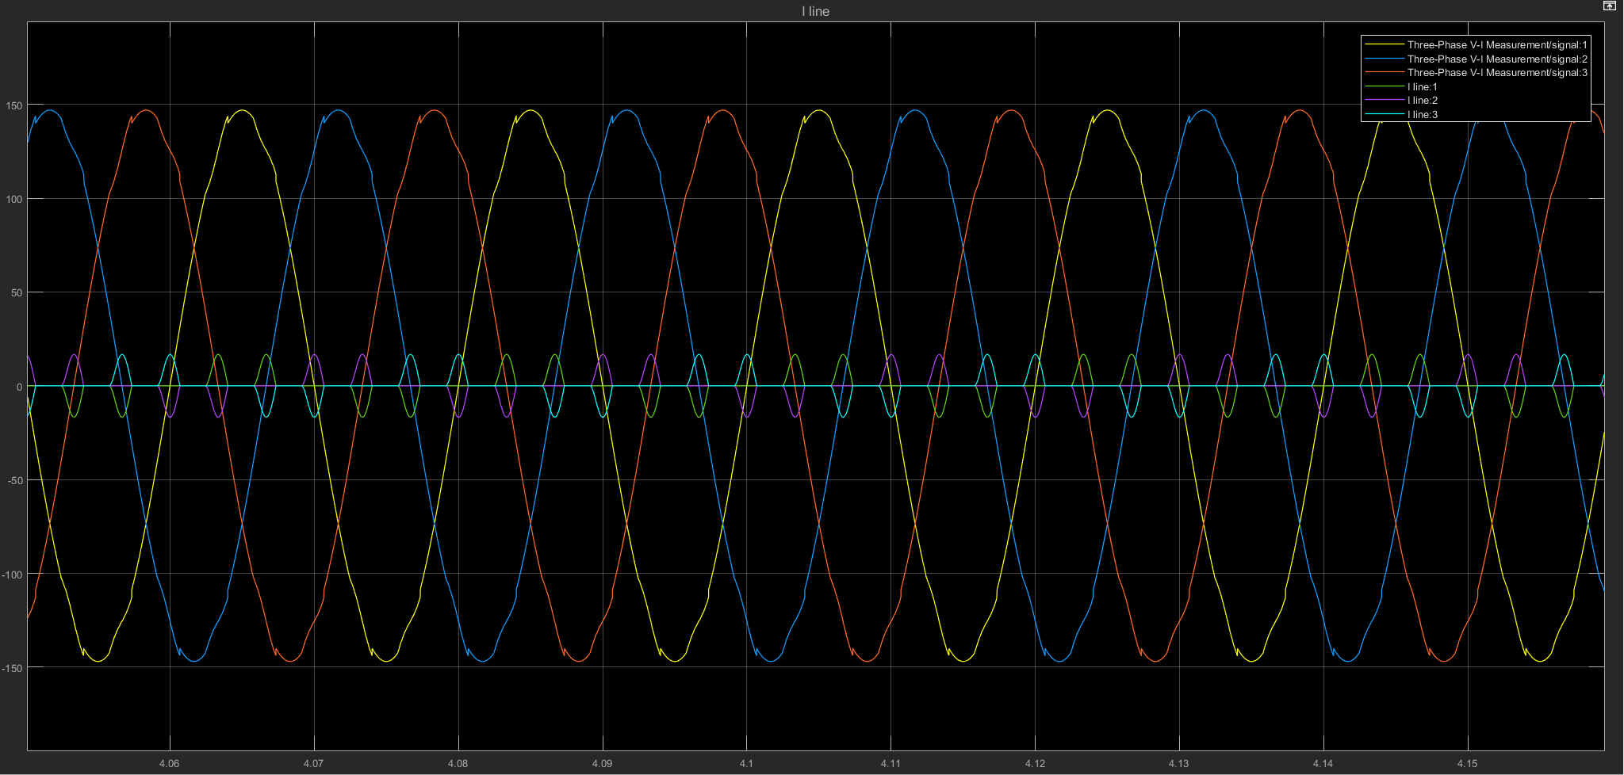

Figure3.2: Three-Phase V-I Measurement (phase to phase 180Vrms)

Figure 3.2 shows the input of the drive system that is the three-phase voltage and the line current. Phase-to-phase 180 Vrms is selected since variac can be used as a soft starter.

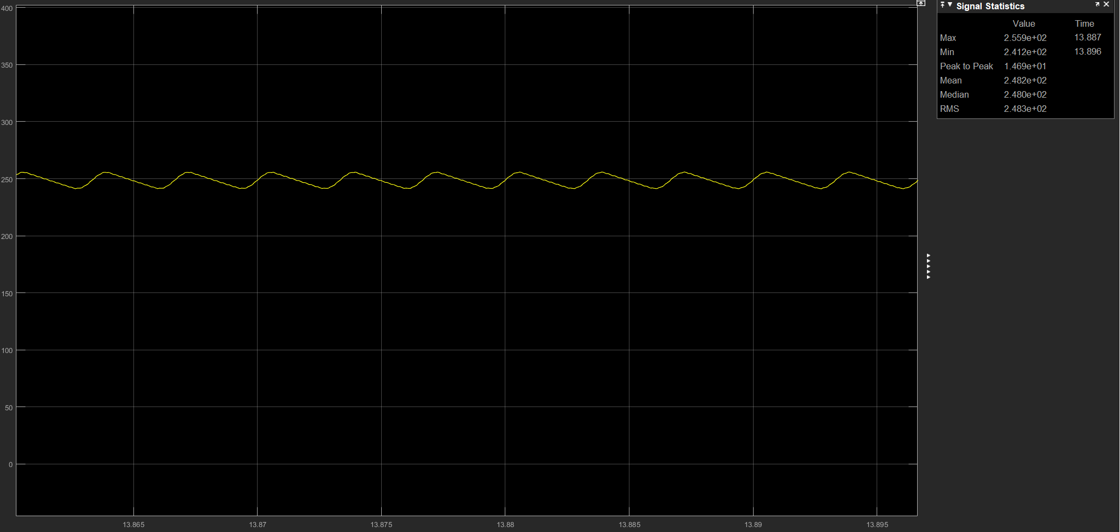

Figure 3.3: Full bridge diode rectifier output voltage with 680µF capacitor

Figure 3.3 shows the rectified input voltage. Since the output ripple voltage is 14.7 V which is insignificant for this project, the 680µF capacitor is good enough to use in the hardware system.

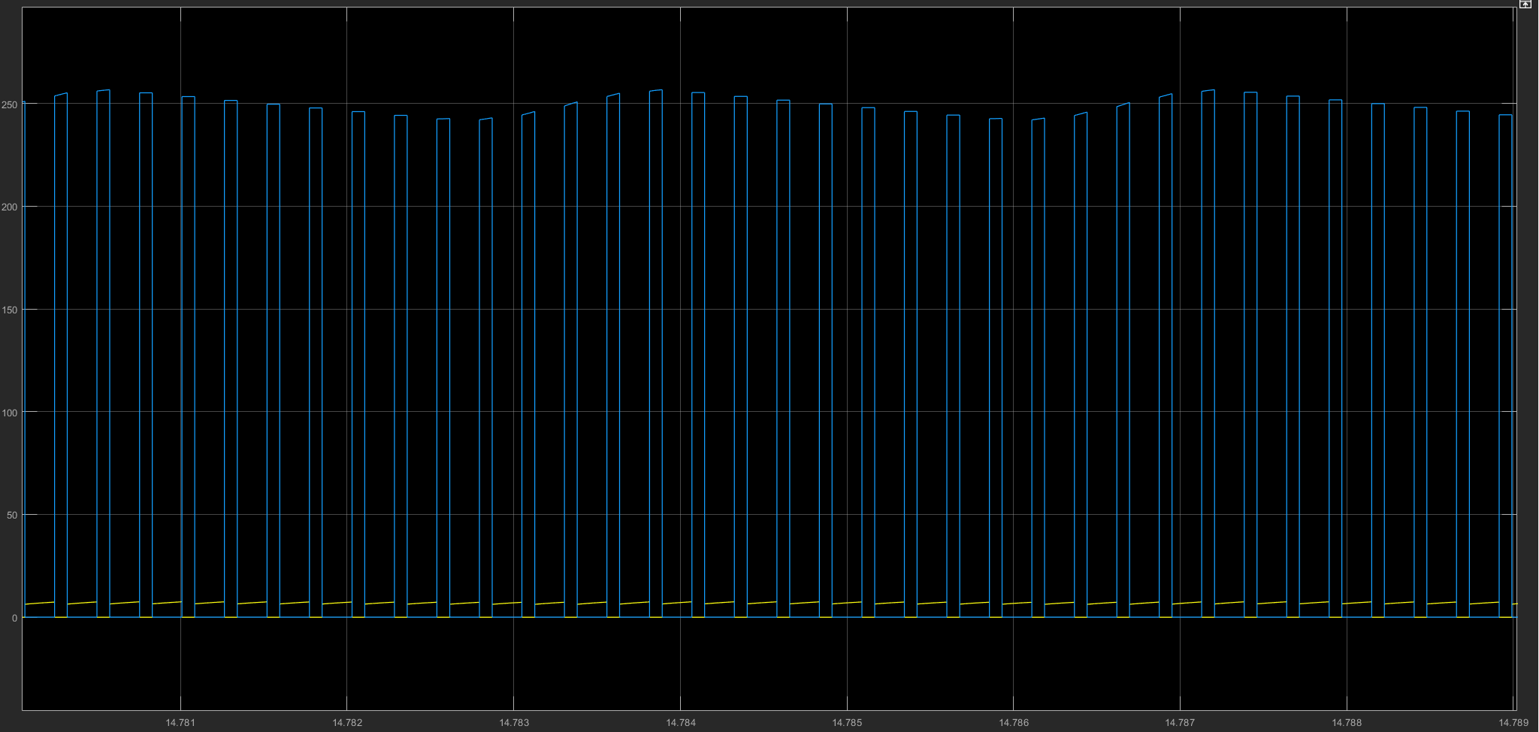

Figure 3.4: IGBT measurement at 70% duty cycle

IGBT voltage is measured 134 V at 70% duty cycle, as can be seen from the figure 3.4, and 181 V at 99% duty cycle.

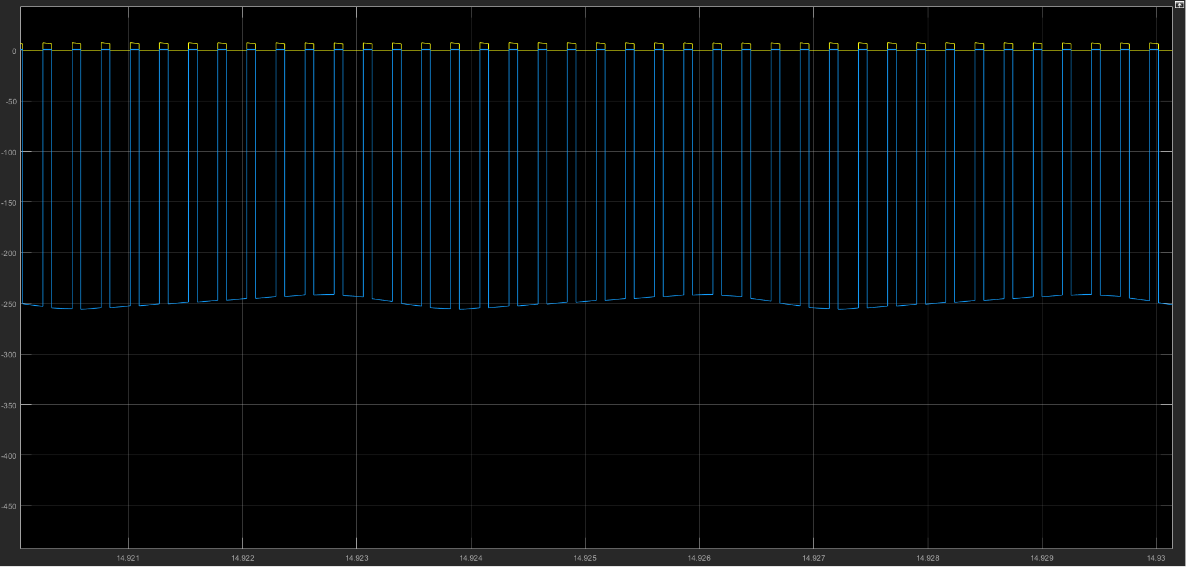

Figure 3.5: FWD measurement at 70% duty cycle

FWD voltage is measured -144 V at 70% duty cycle, as can be seen from the figure 3.5, and -183 V at 99% duty cycle.

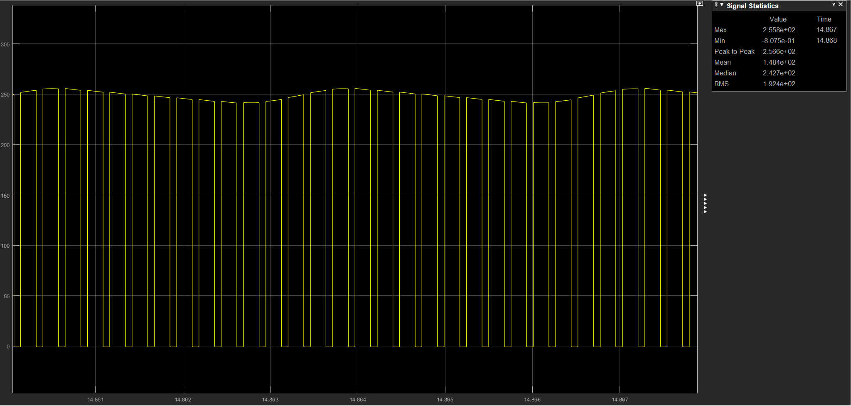

Figure 3.6: DC motor input Voltage at 70% duty cycle

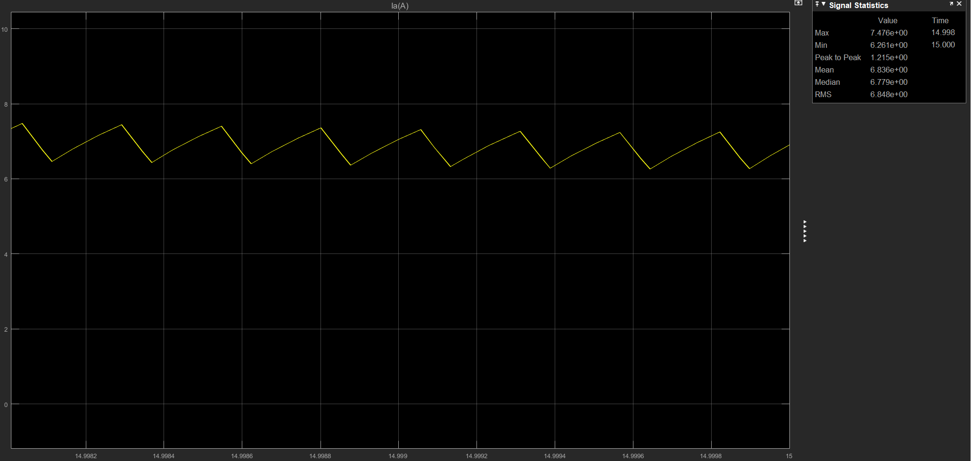

Figure 3.7: Armature current of DC motor

Armature voltage and the current of DC motor at 70% duty cycle are shown in figure 3.6 & 3.7 respectively. Armature voltage is measured 148 V at 70% duty cycle and 191 V at 99% duty cycle. Armature current of the motor is measured approximately 6.83A at 70 % duty cycle in steady state. Electromagnetic torque is measured approximately 0.36 N/m in the simulation when it reaches the steady state as can be seen from figure 3.8.

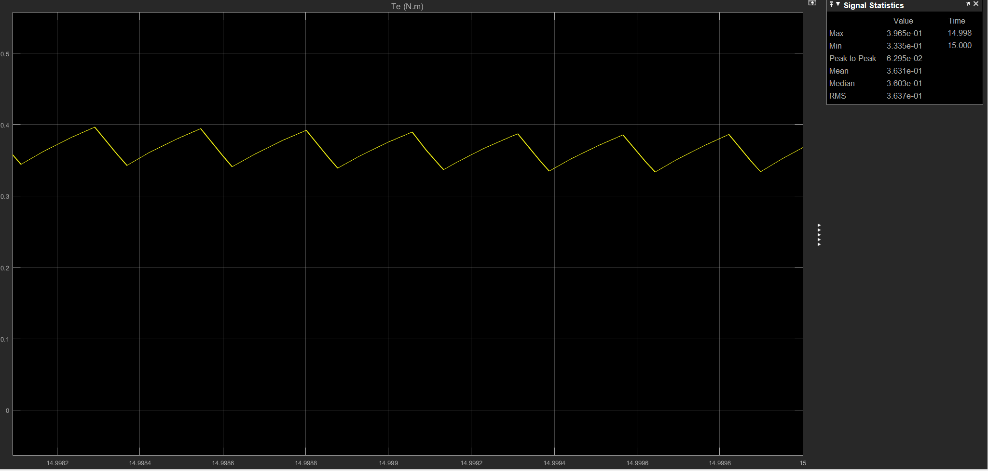

Figure 3.8: Electromagnetic torque of DC motor

As a result of the simulations three-phase diode rectifier, capacitor, IGBT and FWD is selected with a rated voltage higher than 400V and rated current higher than 8 - 12 A.

**Thermal Simulation**

Steady-state thermal analysis for the worst case scenario is implemented on MATLAB/Simulink. Switching loss for 3.9kHz which is the used switching frequency, and maximum conduction loss for extreme case is calculated with the given data of IGBT’s datasheet [1]. The total power loss of 110 W is calculated and inputted for the schematic given in figure 3.9. Thermal resistance value for the IGBT is selected from the datasheet and insignificant (10-5 K/W) thermal resistance value is inputted for the thermal paste. Also, 40 V voltage source is added as ambient temperature.

As a result, heatsink thermal resistance smaller than 0.9 K/W is found sufficient for the system since the junction temperature is 125 ℃ when the thermal resistance of the heatsink is 0.9 K/W. However considering the thermal resistance of the heatsink that was bought from a local store was uncertain, a simple fan is decided to add to the system.

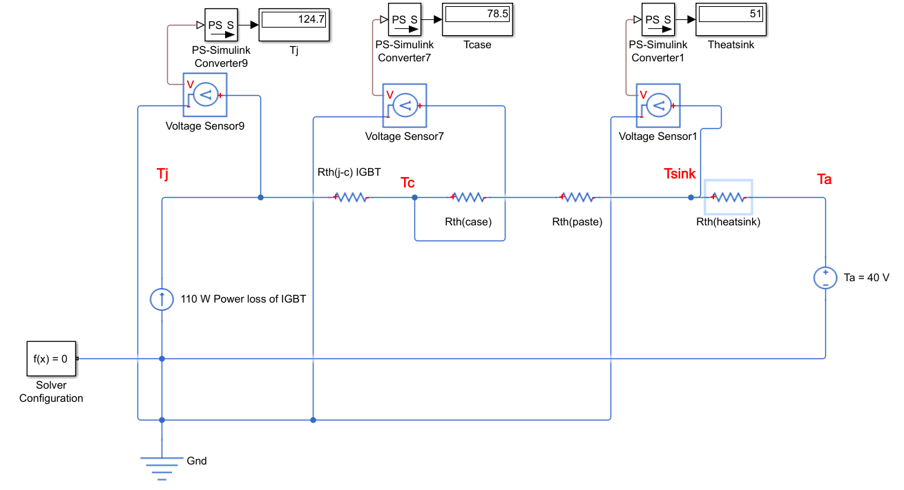

Figure 3.9: Steady-state lumped parameter thermal analysis

# COMPONENT SELECTION

## 4.1 THREE PHASE DIODE RECTIFIER

For three phase diode, based on simulations results the component is selected by multiplying the rated voltage and current with 1.5 in order to stay in the safe zone. Basic three-phase diode rectifier circuit and selected three-phase diode rectifier is in figure 4.1.1.

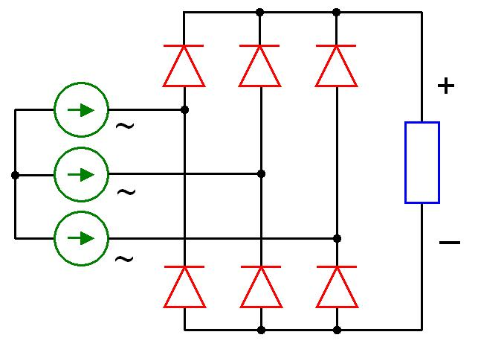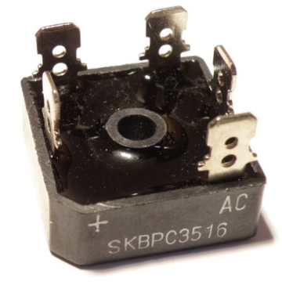

Figure 4.1.1 Three Phase Diode Rectifier

Rated voltage and current of three-phase diode rectifier are;

* Rated Voltage = 400 – 1600 V
* Rated Current = 35 A

By using the three-phase diode rectifier, the dc voltage is obtained at the output terminals of the rectifier. The output voltage is based on input voltage RMS voltage. By adjusting the input voltage by using the variac, dc voltage at the output can be adjusted. The formula of the output voltage is in below;

$V_{dc}=\frac{3\sqrt{2}}{π}*V_{l-l}= ≈1.35 V_{l-l}$

As it seen from the formula when 400 Vrms is given to the input terminals, 540 Volt DC is taken from the output terminals but there is a ripple on the output voltage. The output voltage graph is in figure 4.1.2.

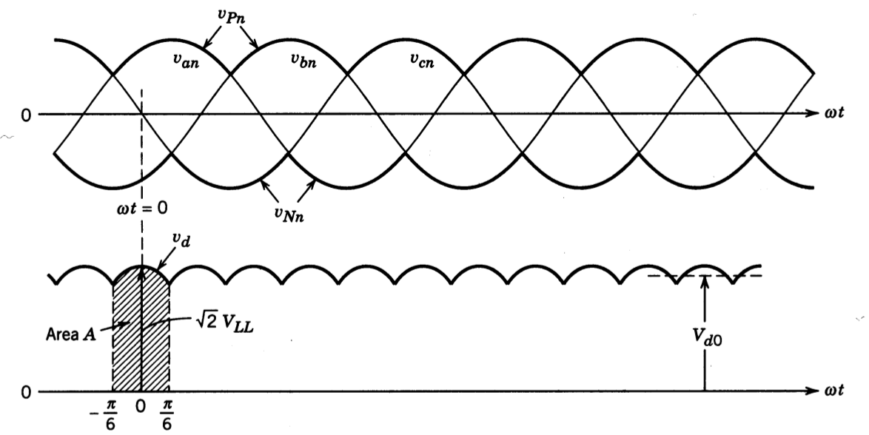

Figure 4.1.2 Output voltage graph of diode rectifier.

As it seen from the figure, there are ripples. In order to eliminate those ripples, dc link capacitor is connected between + and – terminals of output. By using a capacitor, ripples are eliminated. The reason of it is, capacitor keeps the voltage on it and it prevents output voltage the drop, therefore, output voltage almost remains still so it is used to smooth the output voltage of three phase rectifier to achieve pure dc voltage to the motor circuit.

The required capacitor voltage and value for dc link are selected by considering the working voltages. Since the low voltage grid has 400 Vrms for phase voltages, dc link capacitor should be normal when rectifier input voltage is 400 Vrms which means that output voltage of the diode rectifier is 540 Volt. Therefore, capacitor values which are selected for the project are in the table below.

Table 1: Values of the capacitor parameters

|  |  |
| --- | --- |
| Voltage | 600 V |
| Capacitance | 680 µF |

The output voltage graph of the rectifier with the dc link capacitor that has the values above is in figure 4.1.3.

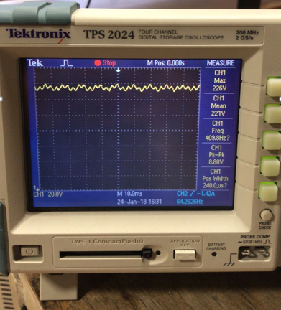

Figure 4.1.3 Output voltage graph with dc link capacitor.

As it seen from the figure 4.1.3, the output voltage peak to peak value is almost 8 V which means that the voltage ripple is %4 which is acceptable for this project.

## 4.2 BUCK CONVERTER

In order to supply the dc voltage to the motor, a buck converter is used for decreasing the output voltage of the rectifier from high dc voltage to desired dc voltage by adjusting the duty cycle of switching component. In buck converter there are 3 main parts, which are;

* IGBT
* Gate Driver
* DC Motor ( Load )
* Free Wheeling Diode

### 4.2.1 IGBT COMPONENT

In order to decrease the output voltage of the rectifier, there are two main switching components which are IGBT and MOSFET for high voltage applications. MOSFET can handle with high switching frequency between 0 – 100 kHz and IGBT can handle the frequency 0- 15 kHz but when the switching frequency increases the losses increases as well, while the component values decreasing. However, since the optimum frequency is around the 5 kHz for this project when losses are considered, IGBT is selected for the switching component.

In order to find the best IGBT, some important conditions are considered such as;

* Rated Voltage
* Rated Current
* Switching Losses
* Thermal Resistance

By considering these conditions the best IGBT component is selected. The selected IGBT is in figure 4.2.1.1. The values of the IGBT is in the table below.

Table 2: The values of the IGBT

|  |  |
| --- | --- |
| Voltage | 900 V |
| Current | 64 A |
| Eoff + Eon | 8.35 mJ |
| RthJC | 0.42 K/W |

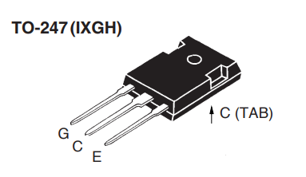

Figure 4.2.1.1 Selected IGBT

After selecting the IGBT component for the circuit of the project, the gate driver is implemented for the drive the IGBT component.

### 4.2.2 DRIVER CIRCUIT

Motor control inverter applications. The high operating voltage range of the output stage provides the drive voltages required by gate controlled devices. The voltage and current supplied by this optocoupler make it ideally suited for directly driving IGBTs with a rating up to 900V/64 A.

For that purpose basically, there are two main options which are HCPL3120 and TLP250. Both are called optocoupler which is amplifying the given PWM signal to desired PWM signal with a desired voltage. HCPL3120 is better than TLP250 for some reasons such as it has better output signal and it can handle higher frequencies but TLP250 is cheaper than HCPL3120, therefore, TLP250 is selected since the switching frequency is around 5 kHz.

TLP250 driver is in figure 4.2.2.1.

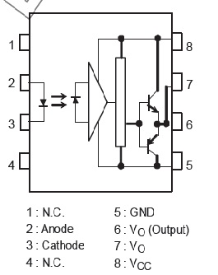

Figure 4.2.2.1 The pin connections of TLP250

### 4.2.3 PWM TECHNIQUE

Pulse with modulations or duty cycle methods is commonly used to control the dc motor speed. Since the PWM is needed for driving the optocoupler, there are two options for generating PWM which are Timer 555 and Arduino. Arduino is selected for generating the PWM because it is easier to implement and use.

By using the Arduino the required pulse with modulation is obtained by adjusting the digital pin frequency of the PWM pins of Arduino and it is 3.9 kHz which is enough for driving the IGBT. Moreover, while frequency is set on a specific value, the duty cycle of that pulse with modulation can be varied by adjusting the reference value. The reference value is set by using the potentiometer, which means that when potentiometer value is changed, the duty cycle changes as well.



Figure 4.2.3.1 Pulses with %0 to %50 duty cycle

As it seen from the figure when duty cycle increases the average voltage increases as well. Therefore, by using both pulses with modulations and optocoupler, the average voltage between the terminals of dc motor can be controlled, in other words, the speed of dc motor can be controlled. The table of the average voltage between input terminals of dc motor is in the table below.

Table 3: Average voltages wrt duty cycle

|  |  |  |  |  |  |
| --- | --- | --- | --- | --- | --- |
| Duty Cycle | %20 | %40 | %60 | %80 | %100 |
| Dc Motor Voltage | 44 V | 88 V | 132 V | 176 V | 220 V |

As it seen from the table, the output voltage of three-phase diode rectifier is set 220 V in order to get rated speed from the dc motor when the duty cycle is %100.

### 4.2.4 DC MOTOR (LOAD)

Dc motors are classified into three main types depending on the way field windings are excited. The connections for the field windings are in figure 4.2.4.1.



Shunt Connection



Series Connections



Compound Motor

Figure 4.2.4.1 Connection types of motor field

As it seen from the above there are three main connection types. Each of them has own advantages and disadvantages. By considering the design of the project, it is hard to find the high inductor value for a buck converter, therefore, using the shunt field connections is seen the best option because of the high inductance value of the connection type. The dc motor which will be used in this project has 13.6 H inductance value for shunt connections which is high enough for the buck converter. Therefore, the shunt field connection is selected.

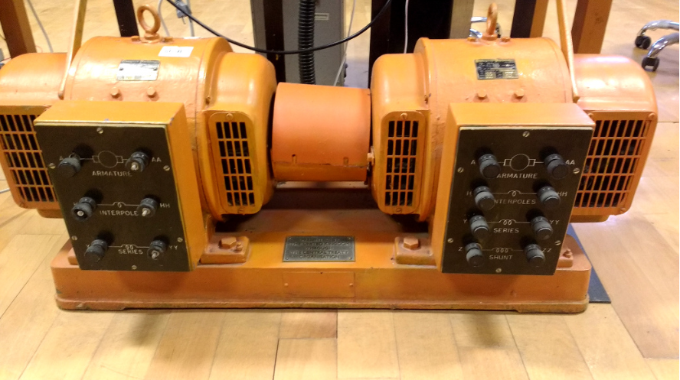

Figure 4.2.4.2: The dc motor which is used in the project.

The inductance values for different connection types are;

* Armature Winding: 28 Ω, 13.3 mH
* Series Winding: 65 mΩ, 260 uH
* Shunt Winding: 8.26 kΩ, 6.4 H
* [Interpoles](https://www.quora.com/Electrical-Machines-What-do-interpoles-do-in-DC-motors) Winding: 0.8 Ω, 5.8 mH
* Inertia: TBA

### 4.2.5 FREE-WHEELING DIODE

The most important reason to use the freewheeling diode is to guarantee the motor current that stays in continuity and protects IGBT from overvoltage due to energy storage in the inductor. For this purpose switch, mode power rectifier in other words diode is used. In order to select the proper diode, voltage rating and current ratings are considered and the diode is selected. The selected diode is in figure 4.2.5.1.

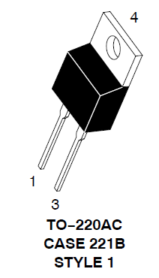

Figure 4.2.5.1 Switch mode power rectifier

Specifications for the selected diode are;

* Voltage Rating: 600 V
* Current Rating: 15 A
* Low Forward Drop: 0.85 V
* Ultrafast 35 and 60 Nanosecond Recovery Time
* 175 ℃ Operating Junction Temperature

# EXPERIMENTAL WORK

In this part of the report, experimental results of the subsystems and the overall system will be given. Furthermore, those results will be explained theoretically. The figure 5.1 shows the overall motor driver we have designed. It has 3 AC inputs, DC inputs for fan and optocoupler, Arduino usb input and 2 outputs to feed motor. Also, duty cycle can be adjusted by rotating the pot seen in the figure 5.2.

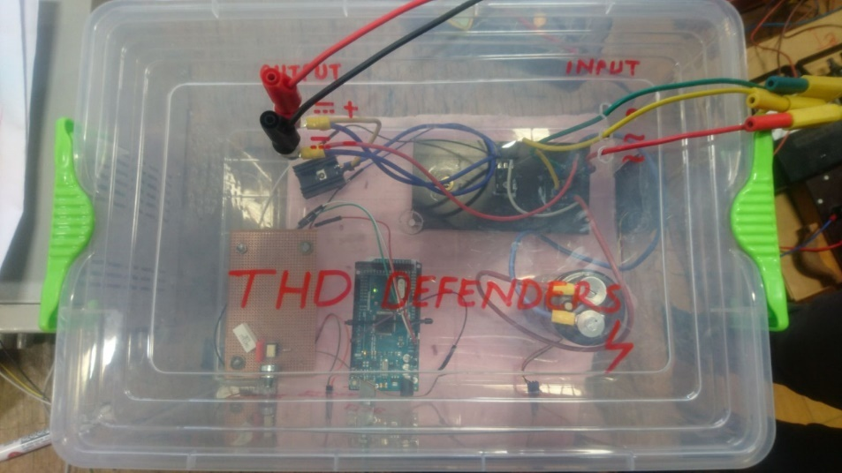

Figure 5.1: Overall view of the project.

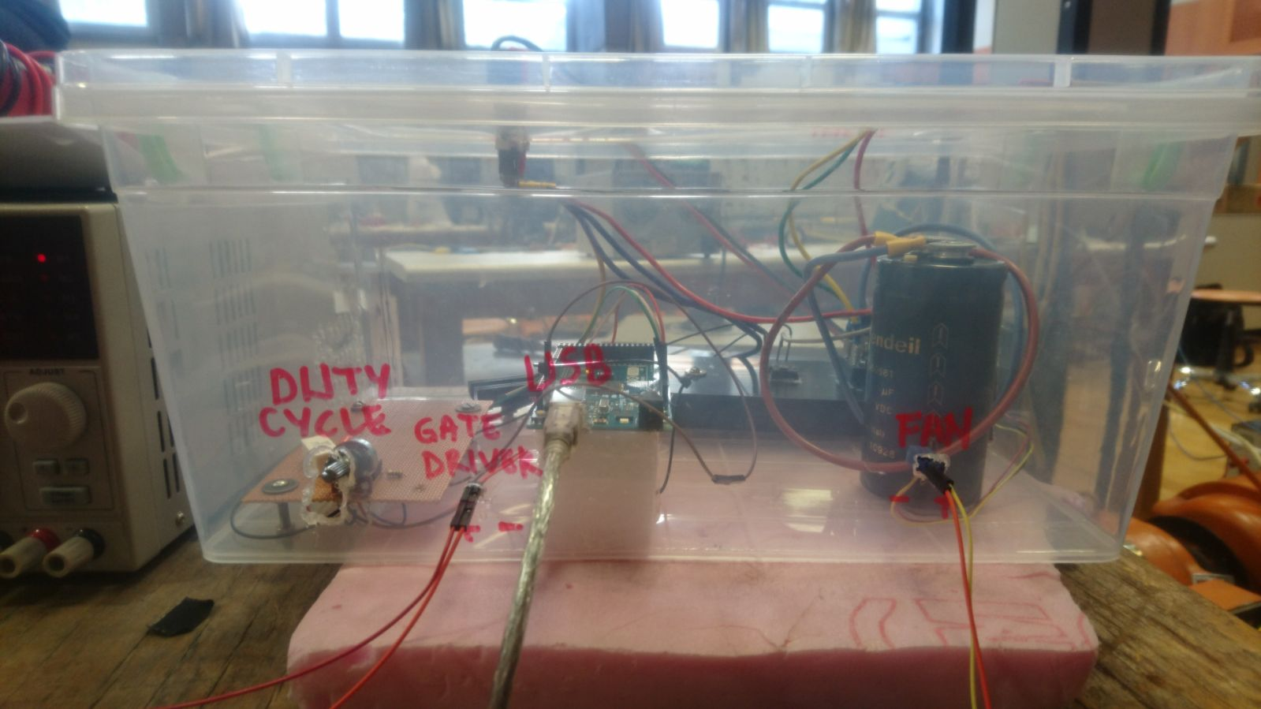

Figure 5.2: Side view of the project.

## Three Phase Diode Rectifier

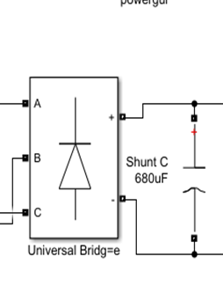

Figure 5.1.1: Three phase diode rectifier connected to capacitor.

As explained previously, inputs of the rectifier are sinusoidal waveforms fed from the variac. Theoretical derivation of the output voltage is conducted earlier in this report. The output of the rectifier is expected to be DC voltage with ripples which has 6 times of the input wave frequency. In other words, output

of the rectifier should be DC voltage with ripples and it should have 300Hz frequency. Figure Z shows the output voltage waveform of the rectifier.

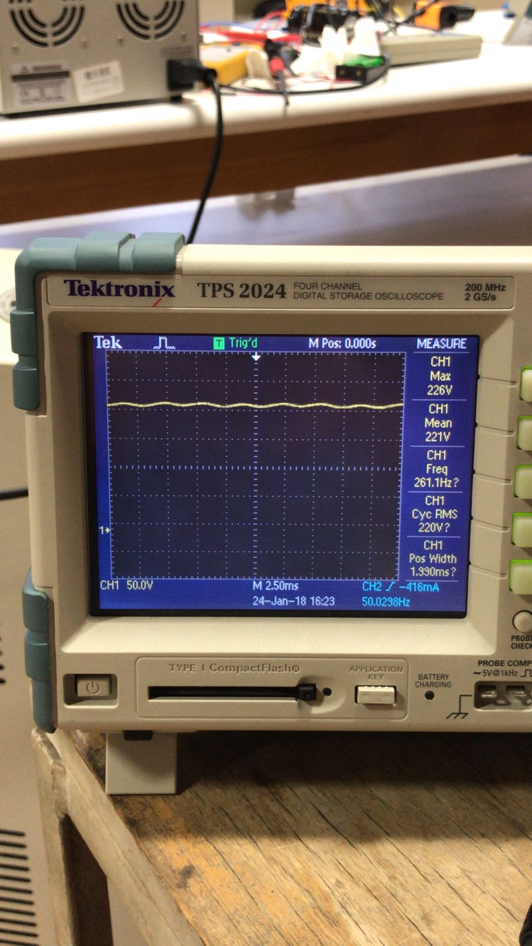

Output voltage waveform of the rectifier.

Out voltage mean value is 1.35 times of the input voltage line to line rms value as expected and it has almost 300 Hz frequency. Despite It is not directly shown in the figure, we have calculated the ripple voltage by subtracting mean value from max value and multiplying by 2. As a result, 10V ripple voltage is observed.

To the output of the rectifier, the 680uF capacitor is placed. The reason for the capacitance addition is related with our design algorithm and explained in the component selection part. The output waveform of the rectifier after capacitor added is given in the figure Z. As expected, the more smooth output voltage is observed. The reason can be explained simply as capacitor together with line inductance eventually work as low pass filter hence higher order harmonics are eliminated. To eliminate all harmonics except fundamental one, a low filter with a corner frequency between 50 Hz and 300 Hz should have been placed.

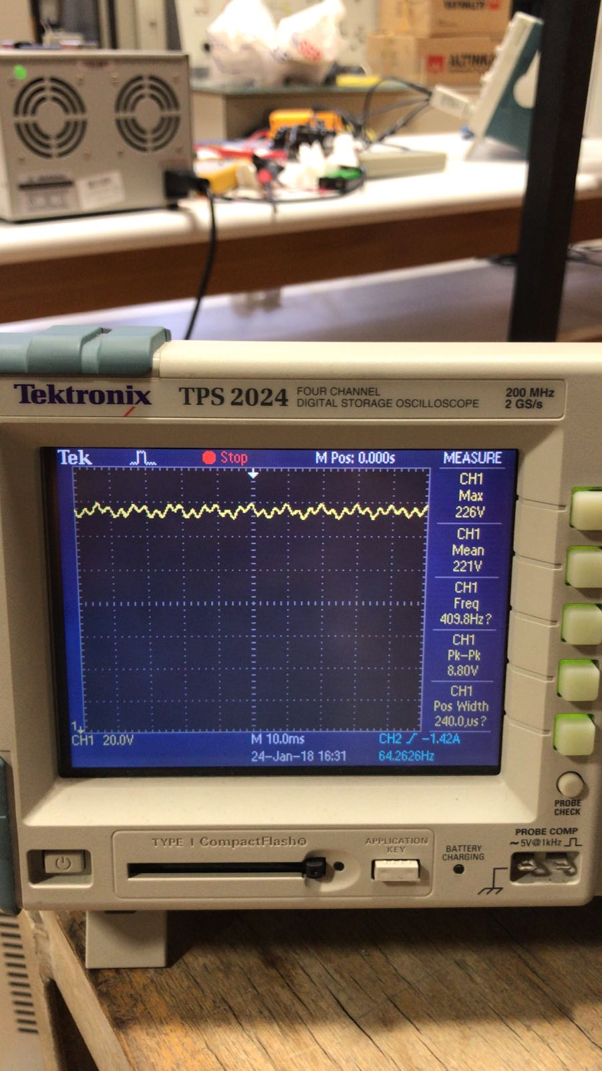

Output voltage waveform of the rectifier when capacitor added.

In our design, since voltage ripple and THD of the input currents are not major concerns, we decided not to use a separate inductor. By not using an inductor, the budget of the project decreased as well. Voltage ripple of the output voltage with a capacitor is measured as 8V peak to peak. To determine THD of the input currents, a current of an input line is recorded and given in the figure Z.

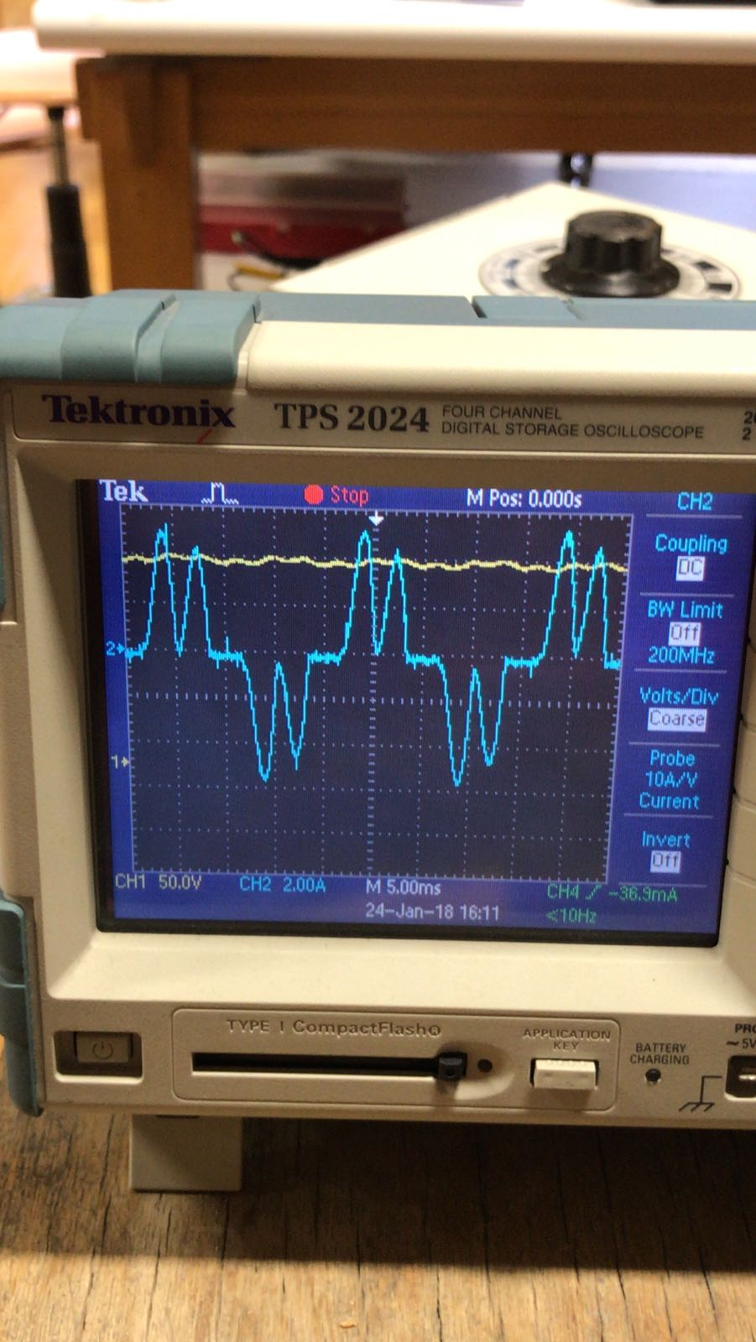

Input current of the system

By using current waveform, thanks to the harmonic analysis of oscilloscope, THD of the input current is measured as 60.2%. Please note that on the demo day, THD is measured as 44.4%. The reason for this difference should be because of the low batteries of the current probes. 44.4% is not very feasible amount however even adding line inductance decreases THD dramatically. The reason why we didn’t add line inductance is simply that of its high cost.

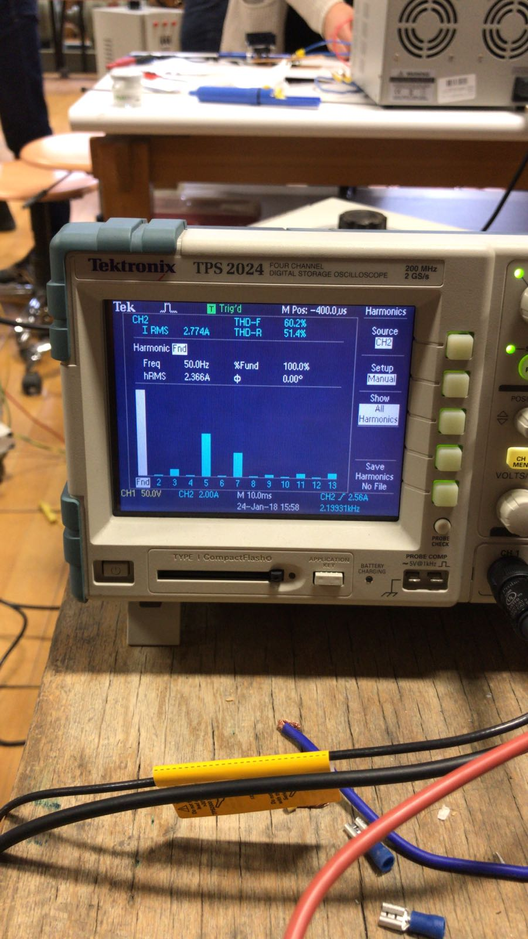

THD analysis of the input current.

## Buck Converter

As explained previously, to control voltage of the terminals of the motor, a buck converter is needed. To do so, IGBT together with freewheeling diode will be used as shown in the figure Z.

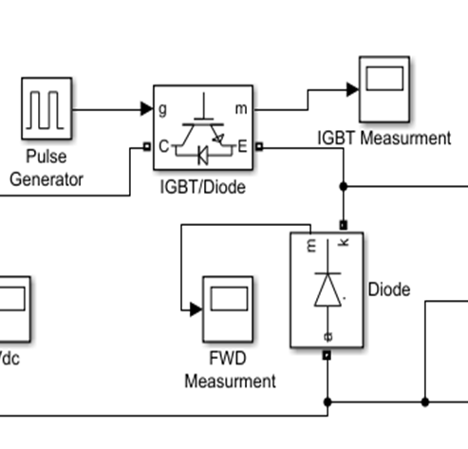

To control IGBT, PWM signal with a maximum value of 15V is needed. The working principle of gate driver circuit is explained earlier in this report. For various duty cycle values, waveforms of the PWM generated are given in the figure Z.

|  |  |  |
| --- | --- | --- |
| *Duty Cycle = 10%* | *Duty Cycle = 30%* | *Duty Cycle = 50%* |
| *Duty Cycle = 70%* | *Duty Cycle = 90%* | *Duty Cycle = 100%* |

Output of the optocoupler for various duty cycles.

As it can be seen from oscilloscope screens, the frequency of the PWM generated is around 3.9 kHz which is expected value calculated in the previous parts.

While the high states of the PWM, IGBT conducts. While PWM is in the low state, IGBT stops conducting. Hence output voltage waveform which is measured between terminals of the diode is just amplified version of the gate signal.

Normally, a buck converter contains a low pass filter to eliminate higher order harmonics. However in our case, since we are working with high frequency and inertia of the motor is quite high, we decided not to use low pass filter. Hence terminals of the FWD is the output of our design.

Output voltage waveforms which are feeding motor armature windings are given in the figure Z.

|  |  |  |
| --- | --- | --- |
| *Duty Cycle = 10%* | *Duty Cycle = 30%* | *Duty Cycle = 50%* |
| *Duty Cycle = 70%* | *Duty Cycle = 90%* | *Duty Cycle = 100%* |

Output of the motor driver system for various duty cycles.

The speed of the motor is proportional to the voltage applied to its armature windings. The voltage applied is the output voltage of the motor driver and motor senses this voltage by mean of it. In other words, mean of output voltage determines the speed of the motor. As it is seen from figures, as duty cycle increases, average output voltage also increases. 100% duty cycle implies that 220V rated voltage applied to armature windings.

## Thermal Design Components

Thermal analysis of our circuit is conducted in previous parts. One of the best ways to show experimental result of thermal analysis is to take a thermal picture of the system. As it is seen in the figure Z, heat of the heat sink connected to IGBT and three phase bridge diode is around 50.5 $℃$. This picture is taken when motor is working under full load. Otherwise we observed 43 $℃$ on the heatsink when motor working with no load.

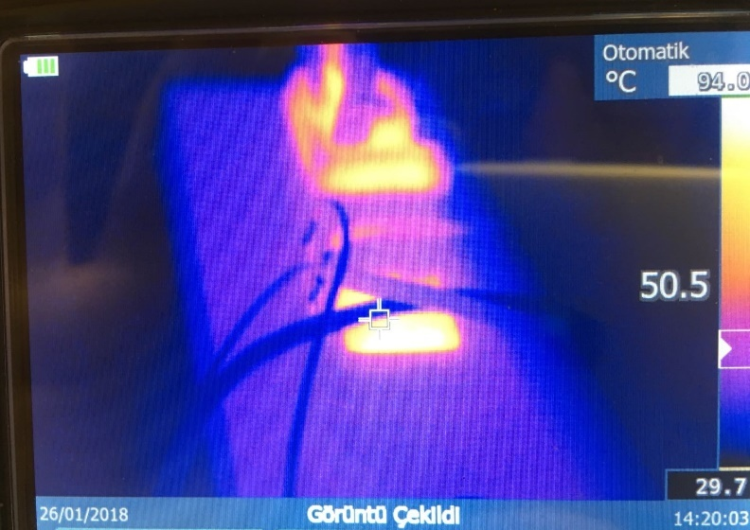

Thermal picture of the motor driver system.

At the beginning we haven’t used fan to cool heat sink, we have observed tempratures over 70 $℃$ in a few minutes under full load. That’s why we decided to use fan to cool our system.

Directions of the heat sinks are also considered. We have placed holes to one side of the box and we have placed fan to just opposite side of the box. So that we obtained air flow from one side of the box to the other side. Furthermore, we have placed heat sinks horizontally to take profit of airflow maximum.

## DC Motor

To determine how motor parameters are changing with duty cycle and loading, experimental data is collected. Those parameters are namely, speed of the motor, armature winding voltage of the motor and armature current of the motor. First data related with duty cycle is given in the table Z.

Table : Motor speed and armature voltage wrt duty cycle.

|  |  |  |
| --- | --- | --- |
| **Duty Cycle(%)** | **Motor Speed(RPM)** | **Armature Voltage(V)** |
| 0 | 0 | 0 |
| 10 | 650 | 30 |
| 30 | 994 | 67 |
| 40 | 1040 | 95 |
| 50 | 1090 | 118 |
| 60 | 1150 | 137 |
| 70 | 1210 | 156 |
| 80 | 1275 | 180 |
| 90 | 1352 | 204 |
| 100 | 1420 | 220 |

To visualize this data, speed and armature voltage vs duty cycle graphs have been drawn.

Motor speed vs. duty cycle graph

Armature voltage vs. duty cycle graph

Secondly, by sweeping loading conditions of the motor, another data set is recorded. It is given in the table Z.

Table : Motor speed and armature current with respect to loading.

|  |  |  |
| --- | --- | --- |
| **Load** | **Motor Speed(RPM)** | **Armature Current(A)** |
| No Load | 1420 | 2.4 |
| 25% | 1388 | 4.5 |
| 50% | 1362 | 6.3 |
| 75% | 1342 | 7.85 |
| Full Load | 1320 | 9.3 |
| Full Load + Kettle | 1260 | 11.2 |
|  |  |  |

To visualize this table, both motor speed and armature current are plotted on the same graph. As loading increases current drawn by the motor also increases where motor speed decreases.

Armature current and motor speed vs. loading.

# POWER AND COST ANALYSIS

In this part of the report, power consumption of the subsystems is given and also prices of the components are given.

At no load and full duty cycle, power consumptions of the optocoupler and fan are given in the figure Z. Other component consumes power is Arduino which operates with 5V and draws 300 mA. 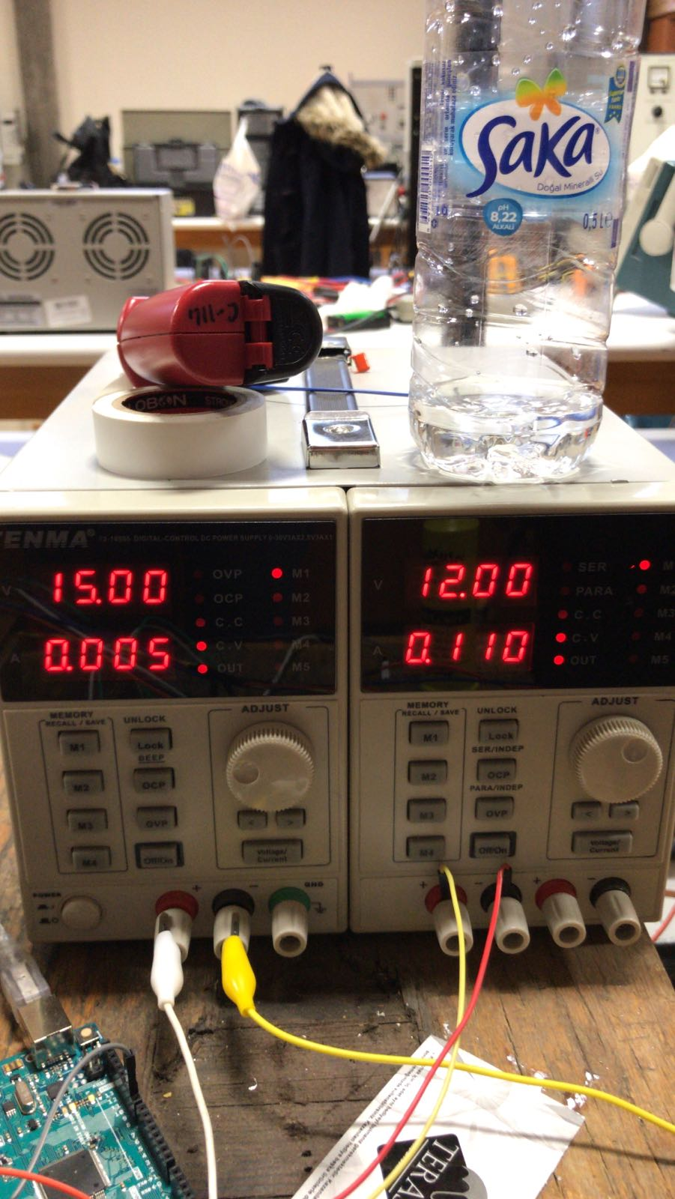

DC power supply supplying power to optocoupler and fan.

Total power consumption is calculated and given in the table Z.

Table Z: Power consumptions of the components.

|  |  |
| --- | --- |
| Component | Power Consumption |
| Octocoupler | 0.075W |
| Fan | 1.32W |
| Arduino | 1.5W |
| *Total* | **2,9W** |

Prices of the components are given in the table Z.

Table Z : Price list of the components.

|  |  |
| --- | --- |
| Components | Price(TL) |
| Capacitor | 40 |
| IGBT | 27 |
| Pertinaks | 20 |
| Diode | 15 |
| Heat Sink | 10 |
| Hard Case | 10 |
| Cables and Connectors | 10 |
| Optocoupler | 5 |
| *Total* | **137** |

# CONCLUSION & COMMENTS

At the end of the project we have achieved a motor driver which is able to drive motor and adjust speed of the motor.

# REFERENCES

[1] Information, A. T. (2005). = 900 V = 64 A, *99384*. Retrieved from http://www.alldatasheet.com/datasheet-pdf/pdf/415170/IXYS/IXGH32N90B2.html

[2] Inverter, I., For, I., Conditioner, A., & Table, T. (2017). TLP250, *5*, 1–7. Retrieved from http://www.alldatasheet.com/datasheet-pdf/pdf/32418/TOSHIBA/TLP250.html

[3] ON Semiconductor. (2014). MUR1520 - Switch-mode Power Rectifiers. *Datasheet MUR1520*, 1–8. Retrieved from http://www.onsemi.com/pub/Collateral/MUR1520-D.PDF

[4]

[5]

# APPENDICES